**INDIRA GANDHI ENGINEERING COLLEGE**

**SAGAR (M.P.)**



A

MAJOR PROJECT-I REPORT

ON

**“Design and Analysis of Single Phase Grid Connected Inverter Using MATLAB Simulink”**

SESSION 2020-2021

Submitted to

Rajiv Gandhi Praudyogiki Vishwavidyalaya, Bhopal (M.P.).

In partial fulfillment of the degree

of

Bachelor of Electrical Engineering

Under the supervision of

Dr. Anurag Trivedi

Head of Dept. of Electrical Engineering

I.G.E.C. Sagar

**Submitted by**

**Krishna Kumar Sharma**

**0601EE171022**

**INDIRA GANDHI ENGINEERING COLLEGE**

**SAGAR (M.P.)**



**CERTIFICATE**



This is to Certify that **Krishna Kumar Sharma** of B.tech. 7th Sem , Electrical Engineering has completed MAJOR PROJECT-I report on ” DESIGN AND ANALYSIS OF SINGLE PHASE GRID CONNECTED INVERTER USING MATLAB SIMULINK**”** towards the partial fulfillment of the requirement for the award of Degree in Electrical Engineering of the **Rajiv Gandhi Proudhyogiki Vishwavidyalya ,Bhopal** for the session 2020-21.

The work presented in this report has been carried out by them under my guidance and supervisions.

Under the supervision of Head of department Principal

**Dr.Anurag Trivedi Dr. Anurag Trivedi Dr. N. L. Prajapati**

Head of Head of

Department of Electrical Eng Department of Electrical Engineering I.G.E.C. Sagar I.G.E.C. Sagar I.G.E.C. Sagar

**INDIRA GANDHI ENGINEERING COLLEGE**

**SAGAR (M.P.)**

**DECLARATION**



I hereby declare that the following document MAJOR PROJECT-I on **“**DESIGN AND ANALYSIS OF SINGLE PHASE GRID CONNECTED INVERTER USING MATLAB SIMULINK**”** is an authentic work done by us. We undertake the project as a part of the course curriculum of bachelor of engineering from electrical engineering of Indira Gandhi Engineering College, Sagar affiliated by Rajiv Gandhi Praudyogiki Vishwavidyalaya, Bhopal (M.P.).

Krishna Kumar Sharma

0601EE171022

ACKNOWLEDGEMENT

I owe a great debt to a number of people who generously gave me so much of their precious time.

Primarily, I wish to express my gratitude to **Dr. Anurag Trivedi**, Head of Department of Electrical Engineering, I.G.E.C., Sagar, the supervisor of my dissertation, for giving me the right direction, excellent references and taking keen interest in the project right from the beginning. He has been a constant source of motivation and inspiration. I have been benefited by his expertise a lot.

I want to express my sincere thanks to **Prof. Rajendra Prasad,** Department of Electrical Engineering, I.G.E.C.for providing the guiding light and always being a force of motivation to experimentally learn new thing.

I am specially indebted to **Miss. Anjali Gupta**, Asst. Prof. and all the faculty members of Department of Electrical Engineering, I.G.E.C. for helping me to complete the project work relatively easier and better.

Krishna Kumar Sharma

0601EE171022

**CHAPTER 1**

**INTRODUCTION**

* **INVERTER MODEL**
* **SINGLE PHASE INVERTER**

**1.INTRODUCTION**

Power inverter is an important part of many DC to AC conversion equipments such as uninterrupted power supply (UPS), induction motor drive and automatic voltage regulator (AVR) systems. In these systems, it is the major requirement for the power inverter to be capable of producing and maintaining a stable and clean sinusoidal output voltage waveform regardless of the type of load connected to it. The main key to successfully maintain this ability is to have a feedback controller.

Photovoltaic (PV) source is one of the significant players in the world’s energy portfolio, and it will make one of the biggest contributions to electricity generation among all the renewable energy candidates by 2040, because it is clean, emission-free, and renewable electrical generation source with the high reliability. The output voltage of pv arrays is relatively low. In order to satisfy the high bus voltage requirements for the full-bridge, half-bridge, or multilevel grid inverter.

A solar inverter can be fed into a commercial electrical grid or used by an off-grid electrical network. The special functions of solar inverters are adapted for use with photovoltaic arrays, maximum power point tracking (MPPT) and anti-islanding protection

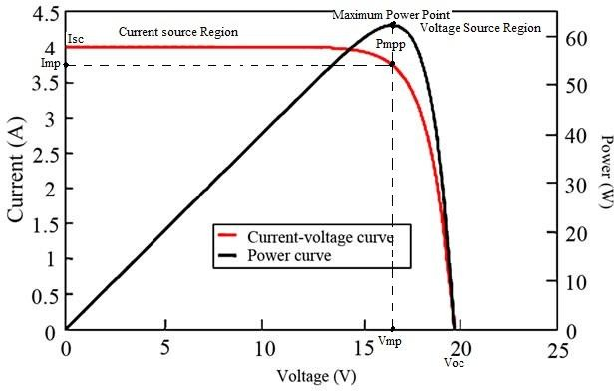

**Fig.1.1.I-V and P-V Characteristics of Solar Cell**

Fig.1.1 shows the I-V and P-V characteristics curve of ideal solar cell. When maximum power is attained by the formula is,

Pmax=Voc * Isc

Where, Voc =open circuit voltage

and Isc=short circuit current.

Pmpp=Vmp * Imp

Where, Vmp =maximum possible circuit voltage and

Imp = maximum possible circuit current.

Current controlled PWM inverters are widely used in high performance AC drivers because they offer substantial advantages in eliminating stator dynamics in those systems. The main objective of current controller is to force the load current vector according to reference current trajectory. The performance of converter systemis mainly dependent upon the type of current control technique is used. In current controller load currents, the errors are used as an input to the PWM modulators, which provides inverter switching signals.

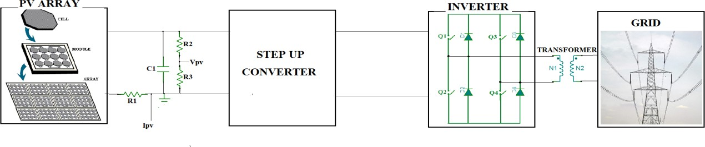

**Fig.1.2Ideal circuit of single phase grid connected inverter**

Fig.1.2 shows the equivalent circuit of a single-phase full bridge inverter with connected to grid. When pv array provides small amount DC power and it fed to the step-up converter. The step-up converter boost the pv arrays output power and its fed to the inverter block. In the inverter converts DC into AC with help of pwm gate switching pulses. Finally synchronization of the phase and frequency of the inverter output voltage with the grid voltage

**1.1 INVERTER MODEL**

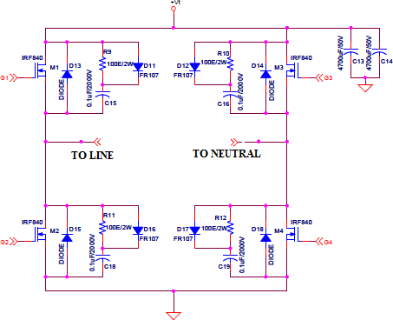In this thesis, four power MOSFETs, IRF840, and fours fast recovery diodes, FR407, are chosen to construct the inverter. The full detail schematic of single phase inverter is illustrated in Fig.1.3 However, IGBTs should be chosen instead of MOSFETs in order to construct a larger scale of the system because IGBTs are cost effective as the rated power increases.

**Fig.1.3 Schematic of the single phase inverter**

The voltage-bidirectional two-quadrant switches have the properties of blocking both positive and negative voltage, but conducts only positive current. When the switch is intended to be in the off state, the controller turns the MOSFET off. The diode then blocks negative voltage, and the MOSFET blocks positive voltage.

The series connection can block negative voltages up to the diode voltage rating, and positive voltages up to the MOSFET voltage rating. However, the positive current will flow from the converter to the distributed line only if when the converter output voltage is greater than the grid voltage plus diode forward-biased voltage. The optical isolated gate driver circuit is used to drive the inverter switches.

The single phase inverter comprises of four switching elements, hence two hi-side gate drive circuits and two lo-side gate drive circuits are required. Each of hi-side circuit must be separately powered and grounded, as shown in Fig.3., because the switch Q3 and Q4 are not electrically connected. The first hi-side circuit is powered by VDD3 and provides “Hi1” command, while another hi-side circuit is powered by VDD4 and commands the switch Q4 via “Hi2” command.

In contrast, both of the low-side circuit can be powered and grounded by the same power supply, which is VDD5 respected to an analog ground “2”, because both of switches Q5 and Q6 are electrically connected.

CHAPTER 2

**SOLAR ENERGY**

* **INTRODUCTION**
* **SOLAR SYSTEM CONFRIGURATION**
* **SINGLE-STAGE CENTRALIZED INVERTER**
* **SINGLE-STAGE STRING INVERTER**
* **TWO-STAGE STRING INVERTER**
* **TWO-STAGE CENTRALIZED INVERTER**
  + 1. **2.SOLAR ENERGY**

Solar energy systems convert the energy of the sun directly to electrical energy. Solar energy farms can generate a significant amount of electricity to feed the electrical systems.

Scaled-down solar systems can provide sufficient energy for residential and business utilization. The solar cell is similar to a diode, and a practical model of the solar cell is given in Fig. 2.1.

The milliohms level resistance RS represents the collector traces and external wires, and the parallel kilo ohms level resistance R€ is the internal resistance of the crystal.

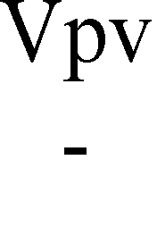

**Fig. 2.1: Equivalent circuit of a solar cell**

The PV cell output current is derived as (1.1). The source current IL is dependent on the solar irradiance. Since the thermal voltage VT and the reverse saturation current IS are dependent to the temperature, the PV output current IPV is dependent on the temperature. Thus, the PV output current is actually a function of irradiance and environmental temperature. Based on the practical solar cell model, PV output current-voltage (I-V) and power-voltage (P-V) curves are plotted with different irradiances and temperatures. The PV output I-V and P-V curves are created by varying irradiance. In Fig. 2.1, Isc is the short circuit current and Voc is the open circuit voltage. The PV output I-V and P-V curves are created by varying temperature.

IPV = IL − ID − Ip = IL − IS(evD⁄yVT − 1) − vDC

R

Since the maximum power output of PV changes as the irradiation and environmental temperature varies, maximum power point tracking algorithm must be implemented in PV applications to obtain the maximum power from a PV string for the sake of conversion efficiency. Many MPPT algorithms have been proposed and implemented. The most common and basic MPPT techniques are perturb and observe (P&O) algorithm, incremental conductance algorithm, and fractional open-circuit voltage algorithm .

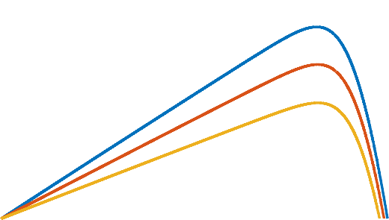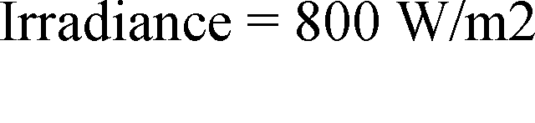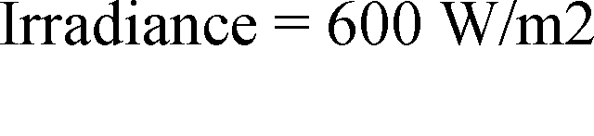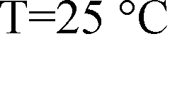

MPP

**Fig. 2.2: P-V curves of a PV string (constant temperature**

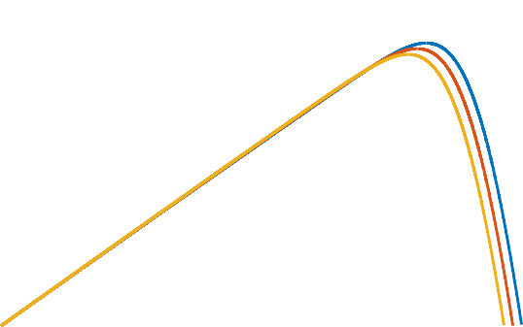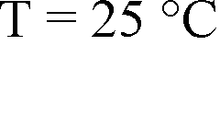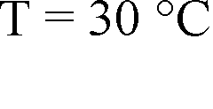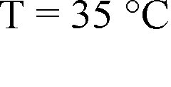

**Fig. 2.3: P-V curves of a PV string (constant irradiance)**



**2.1 Solar System Configurations**

Photovoltaic modules feed DC current and voltage into the power electronics system. DC to DC converters are often used to amplify the low voltage generated by PV modules. And the inverters are utilized to convert the high level DC voltage to the AC voltage to supply the normal loads. The solar panel configuration affects the power electronics systems design. As to what configurations to choose, it depends largely on the residential environment and cost budget. Four basic solar system configurations are listed and discussed in the following session.

**2.1.1 Single-Stage Centralized Inverter**

In this configuration, PV panels are connected in series to form a PV string, in order to reach a higher voltage. These PV strings are then connected in parallel with power diodes to achieve higher power generation. This configuration is shown as in Fig.

**Fig. 2.4: Single-stage centralized inverter**



In this configuration, it can be seen that all the PV strings are in parallel, and thus all the PV strings share the same voltage. Because of the irradiation shading or panel mismatch problems, the operating voltage may not be the maximum power point for all the PV strings. This may result in poor energy harvesting. The benefit of choosing this configuration is its low cost .

**2.1.2 Single-Stage String Inverter**

Another single-stage PV inverter configuration is shown in Fig.2.5 In this configuration, each PV string can have its own maximum power point if there is any partial shading or panel mismatch. Each string inverter is supposed to handle its own maximum power point tracking and power conversion control. For the power harvesting performance, string inverter configuration is superior compared to the single-stage centralized inverter. However, the string inverter configuration increases the total installation cost because an inverter is applied to each PV string .



**Fig.2.5: Single-stage string inverter**

**2.1.3 Two-Stage String Inverter**

A two-stage string inverter configuration is shown in Fig.2.6 This configuration is popular due to its improved energy harvesting capability, modularity, and design flexibility. Each PV string contains less solar panels which increases the system robustness. The first stage is to amplify the low DC voltage generated by solar panels to a higher level DC bus. The DC to DC converter should also handle the maximum power point tracking. The second stage controls the power conversion from DC to AC.



**Fig.2.6: Two-stage string inverter**

**2.1.4 Two-Stage Centralized Inverter**

A two-stage centralized inverter configuration is shown in Fig.2.7 The first stage is a modularized DC voltage amplification stage. The DC to DC converter handles the maximum power point tracking for the connected PV string. The second stage is a centralized DC to AC inverter. The following inverter design of this thesis is based on two-stage inverters. Using this configuration may reduce the cost of inverter stage; however, the centralized inverter can be larger.



**Fig. 2.7: Two-stage centralized inverter**

**CHAPTER 3**

**INVERTER FILTER TOPOLOGIES**

* **L type filter**
* **LC type filter**
* **LCL type filter**
* **LLCL type filter**
* **LCL Filter Design Considerations**

**3.Inverter Filter Topologies**

For all H-bridge inverters, a low-pass output filter is needed to obtain the fundamental frequency output. Generally, there are four different types of H-bridge inverter filters. They are L filter, LC filter, LCL filter, and LLCL filter, respectively .

The L type filter, shown in Fig.3.1, consists of an inductor only. Over the entire frequency range, L type filters have an attenuation of -20 dB/dec. In order to suppress the output current harmonics, a high value inductor is needed. A large inductance leads to a larger filter size and higher cost. The high voltage drop over the big inductor worsens the system dynamics.

**Fig. 3.1: L type filter**



The LC filter, shown in Fig.3.2, is a second-order filter with an attenuation of -40 dB/dec . The LC filter design process is fairly easy. The trade-off of the design is that a higher capacitance may help reduce the cost of the inductor. However, the system may encounter inrush current and high reactive current flow into the capacitor at the fundamental frequency. If an inverter is tied to the grid through an LC filter, the resonance frequency of the filter becomes dependent upon the grid impedance . However, the LC filter is good fit for stand-alone inverters due to its compact size and good attenuation performance.

**Fig. 3.2: LC type filter**



The third-order LCL filter, displayed in fig3.3, is widely used with grid-connected inverters due to its high attenuation beyond resonance frequency. Compared to the LC filter, the LCL filter gives a better decoupling capability between the filter and the grid impedance .

The design process of the LCL filter has to consider the resonance of the filter and the current ripple flowing through the inductors. Detailed LCL filter design procedures are given in the following section.



**Fig. 3.3: LCL type filter**

Another inverter filter configuration, the LLCL filter, is developed based on the LCL filter. A very small inductor is placed in series with the filter capacitor. The structure of this LLCL filter is shown in Fig.3.4. Compared to the conventional LCL filter, the LLCL filter can further reduce the grid-side inductance with a tuned trap at the switching frequency.

However, the design and modeling process of the LLCL filter is relatively complex due to its high-order nature.



**Fig. 3.4: LLCL type filter**

The Bode plot shown in Fig.3.4 displays an L filter, LCL filter, and LLCL filter in frequency domain. It can be seen that the LLCL filter has the same frequency response characteristics as the LCL filter at the low frequency. Both of the two filters require design attention to the resonance frequency, which may lead to an unstable system.

200



-20 dB/dec

L filter

LCL filter LLCL filter

-60 dB/dec

100

0

-100

-200

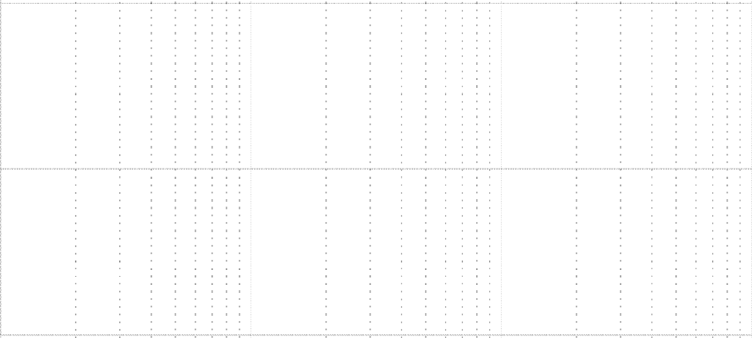

-300

-90

- 180

-270

102 103 104 105

**Frequency (Hz)**

**Fig. 3.5: Bode plot of different filter types**

**3.1 LCL Filter Design Considerations**

Based on the above inverter filters review, a LCL type filter is chosen due to its good performance and relative simplicity. The LCL filter design procedures are described and discussed in . Typically, the filter design requirements for the grid-tied mode are stricter than the design requirements for the stand-alone inverter. The filter designed for the grid- tied inverter will satisfy the stand-alone inverter operation. The inverter-side filter inductance selection is based on the allowable maximum current ripple and harmonic current attenuation.

The capacitance is selected based on the reactive power absorbed at the rated conditions.

To design an LCL filter, there are some guidelines to follow. The total inductance (L1 + L2) should be less than 10 % of the system base inductance to avoid large voltage drop across the inductors . The current ripple should be limited to 20 % of the rated current. The capacitance can neither be too large nor too small. A small value capacitance diminishes the attenuation capability of the LCL filter; however, a large value capacitance leads to a high reactive power.

The resonance frequency of the LCL filter should always be designed within the range of (1.2) to ensure good system dynamics and avoid resonance problems . In (1.2), fg represents the grid fundamental frequency and fs is the inverter sampling frequency. The grid-side inductance L2 should only be a fraction of the inverter-side inductance L1to ensure the system stability. Last but not least, the inverter current output harmonics should be limited according to IEEE 519-1992 .

10fg < frec < 0.5fc

The PWM modulation type affects the inverter filter design. Unipolar modulation is popular due to its higher efficiency. With the same carrier frequency, the equivalent switching frequency of the unipolar modulation is doubled compared to the switching frequency of the bipolar modulation method. Thus, the LCL filter size is smaller when unipolar modulation is applied. However, bipolar modulation has much less leakage current than unipolar modulation in a PV inverter without galvanic isolation.

With the configuration as in Fig.3.6 (Rg = 0.4 Ω, Cp = 5 nF), a comparison of the leakage current in the PV inverter is performed between unipolar and bipolar switching with the same equivalent switching frequency. The pink line in Fig.3.6 shows the leakage current in a PV inverter when unipolar switching is applied, whereas the pink line in Fig.3.6 shows the leakage current in a PV inverter when bipolar switching is used. In this thesis, bipolar modulation is adopted, since the inverter is mainly designed for a two-stage PV inverter without galvanic isolation.

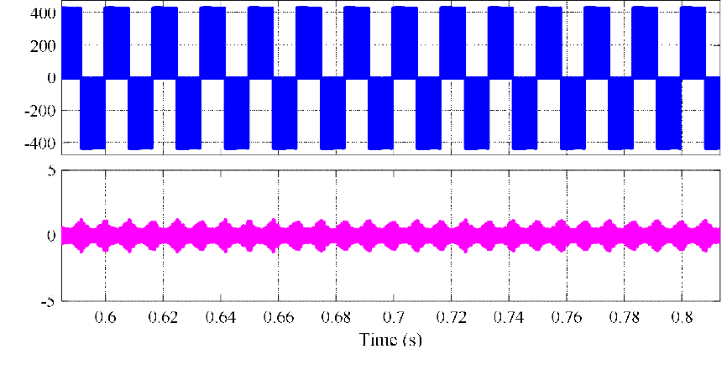

Voltage (V)

Current (A)

**Fig. 3.6: PV inverter leakage current with unipolar switching**

Voltage (V)

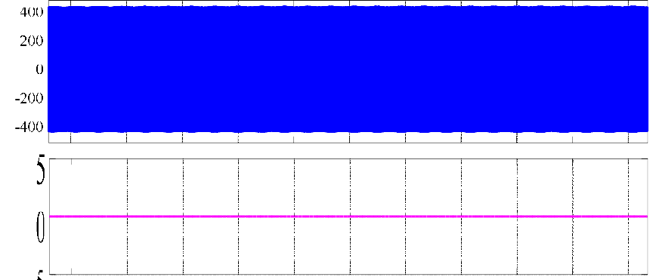

Current (A)

Current (A)

**Fig. 3.7: PV inverter leakage current with bipolar switching**

To derive the LCL filter transfer function, the grid voltage is considered to be an ideal source which is a short circuit for all harmonics. Thus the grid voltage is set to be zero. The derived LCL filter transfer function. The resonance frequency is shown in the undamped LCL filter Bode plot. The resonant poles introduced by the LCL filter may affect the system stabilit, a passive damped LCL filter is often used in the conventional PV inverter design.

The damping resistor is either placed in parallel with the filter capacitor or in series with the filter capacitor as illustrated in Fig.3.7. The damped LCL filter transfer function is derived as in when the damping resistance is in series with the filter capacitor. The passive damped LCL filter frequency response is shown in Fig.3.8. However, it is obvious that the damping resistor reduces the efficiency of the overall system. Thus, an active damping method is preferred.



**Fig. 3.8: LCL filter passive damping resistance placement**





LCL filter

Damped LCL filter



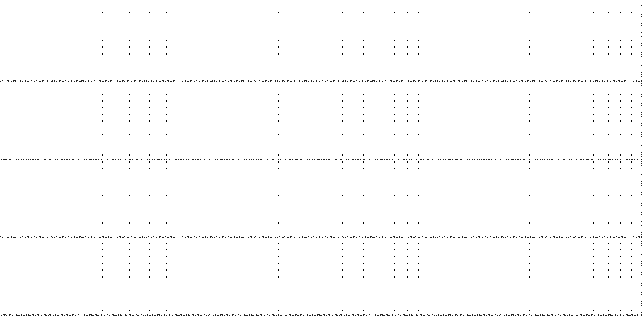

Frequency

**Fig. 3.9: LCL filter with passive damping resistance**

CHAPTER 4

**CONTROLLER DESIGN OF INVERTER**

* **Inner current loop design**
* **Inner current loop design**
* **DQ Frame control**
* **Proportional resonant control**
* **Summary**
* **PWM Pulse generator**
* **Introduction**
* **Major advantages of PWM technique**
* **Hysteresis Controller**
* **Zero Crossing Detector**

**4.Controller Design of Stand-Alone Inverter**

Residential inverters are expected to be able to work off-grid to support critical loads as uninterruptible power supplies. The design of a dual-loop controlled stand-alone inverter is described in this chapter. The inner loop regulates current, and outer loop regulates inverter output voltage across the capacitor of the filter. The inner current control loop can either regulate the current flowing through the inverter-side inductor, or current flowing through the capacitor of the filter. Since traditional PI controllers cannot achieve zero steady-state error while tracking sinusoidal signals, direct quadrature (DQ) frame controllers and PR controllers are investigated and applied. Using the synchronous frame outer control loop, a comparison on the control performance between the two inner current feedback methods is performed. The island mode inverter circuit and conventional control diagram is given in Fig. 4.1 Simulation results are provided within this chapter.

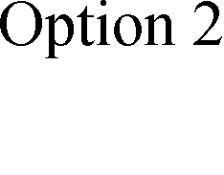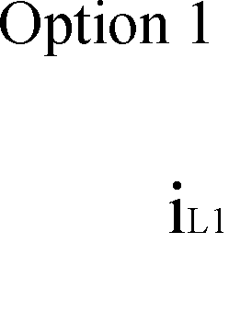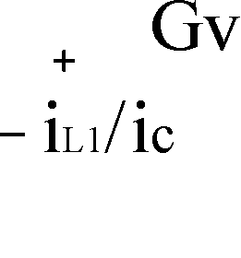

**Fig. 4.1: Island mode inverter circuit diagram**

**4.1 Inner Current Loop Design**

Generally, the current inner loop has two options. One is to use the inverter-side inductor current iL1 as the feedback value. The other one is to adopt the current flowing through capacitor i€ as the feedback value. The control diagrams of inner feedback systems using both options are shown in Fig. 4.2 and Fig. 4.3, respectively. Comparing these two control diagrams,

it is seen that the capacitor current feedback control method includes the load current within the control loop. Thus, by using capacitor current feedback method, the system can obtain better performance when load changes. According to, the worst control design condition for stand- alone inverter is in no load condition. Therefore, the load current is assumed to be zero in Fig. 4.2. Thus, the control plants in Fig. 4.2 and Fig. 4.3 are identical.



**Fig. 4.2: Inner control system diagram using inverter-side inductor current iL1 feedback**



**Fig. 4.3: Inner control system diagram using capacitor current i€ feedback**

At least one switching period delay Ts should be considered for digital implementation since the modulation signal will not update until the next switching cycle . The delay block Gd shown as (2.1) is a second order Pade approximation of the pure switching cycle delay.

According to the derived small-signal mode in , the inverter stand-alone mode control plant GP is given as (2.2). The control diagram shown in Fig. 4.3, the uncompensated inner control loop plant can be derived as (2.3). A PI controller is used as the compensator for the inner control loop. The compensated open loop is derived as (2.4) in the Laplace frequency domain.

The PI compensator is designed to boost the phase margin of the uncompensated transfer function (2.3) to increase the system stability. The crossover frequency of the compensated system should be less than one tenth of the switching frequency for good switching noise rejection, and higher than ten times of the grid frequency for fast dynamics. The desired phase margin and gain margin are larger than 45 degrees and 7 dB, respectively. The uncompensated and compensated Bode plots are shown in Fig.4.4.

The blue line is the Bode plot of the uncompensated plant. The green line shows the open-loop Bode plot of the compensated system. As we can see from Fig.4.4, the phase margin is 48.4 degrees, the gain margin is 8.14 dB, and the crossover frequency is designed to 2.9 kHz. The stability of the compensated system is verified by Nyquist stability criterion. The PI compensator is given as (2.5). The unit step response is shown in Fig.4.5. The step response overshoot is 24.6 % and the settling time is 0.831 ms.

Uncompensated inner loop Compensated inner loop

System: Compensated inner loop Gain Margin (dB): 8.14

At frequency (Hz): 7.32e+03 Closed loop stable? Yes

Magnitude (dB)

System: Gop_c

Phase Margin (deg): 48.4 Delay Margin (sec): 4.66e-05 At frequency (Hz): 2.89e+03 Closed loop stable? Yes

Phase (deg)

Frequency(hz)

**Fig. 4.4: Bode plots of the uncompensated and compensated inner loop**

Step response

System: Gcl_c

Settling time (seconds): 0.000831

Amplitude

Time(seconds)

**Fig. 4.5: Step response of the compensated inner control loop**

**4.2 Outer Current Loop Design**

The outer control loop is designed to regulate the inverter output voltage across the filter capacitor C. The simplified control diagram is shown in Fig. 4.6.



1

Cs

**Fig. 4.6: Outer loop control diagram**

The outer loop PI controller is designed to provide a satisfactory phase margin for the uncompensated plant to achieve the system stability. The crossover frequency of the dual-loop compensated system should be approximately ten times larger than the grid fundamental frequency and less than the inner loop crossover frequency. The uncompensated and compensated Bode plots are shown in Fig.4.6. The blue line is the Bode plot of the uncompensated plant. The green line shows the open-loop Bode plot of the compensated system

As we can see from Fig. 4.6, the phase margin is 62.2 degrees and the gain margin is 13.7 dB. The crossover frequency is about 725 Hz. When the gain of the compensated open-loop system is higher than 0 dB, there is no negative or positive phase crossing through the +/- 180º phase line. The number of the compensated open-loop system RHP poles is zero. According to Nyquist stability criterion, the compensated closed-loop system is stable. The PI compensator is given as (2.6). The unit step response is shown in Fig. 2-8.

The step response overshoot is 16.4 % and the settling time is 2.32 ms. Apply the designed current loop PI controller and voltage loop PI controller to the MatlabTM Simulink circuit model, the outer loop voltage tracking error is shown in Fig.4.7. The voltage tracking error shown in Fig.4.9 has a peak value of 22 V at the fundamental frequency. To eliminate the voltage tracking error, a synchronous rotating frame DQ control or a stationary reference frame proportional resonant control should be adopted . More detail is given in the following sessions.

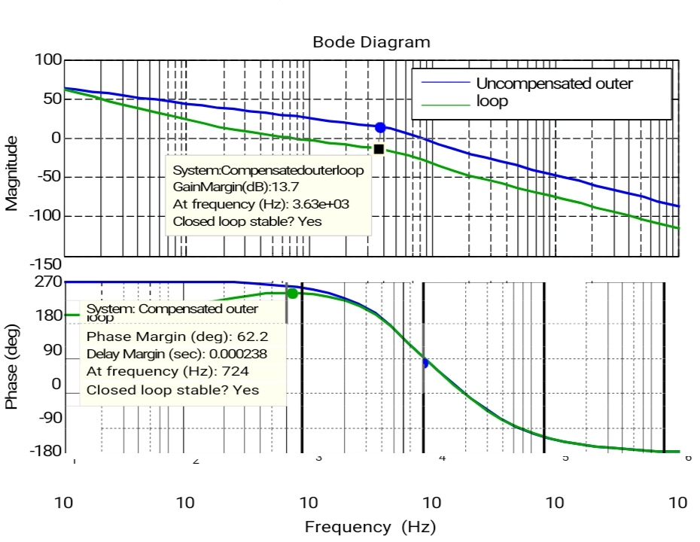

**Fig. 4.7: Bode plots of the uncompensated and compensated outer voltage loop**

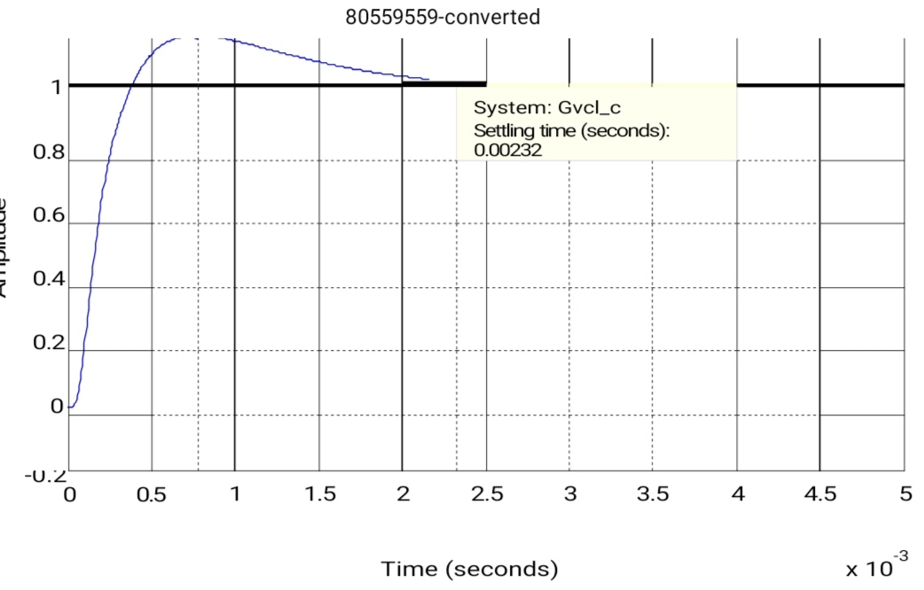

**Fig. 4.8: Step response of the compensated outer voltage loop**

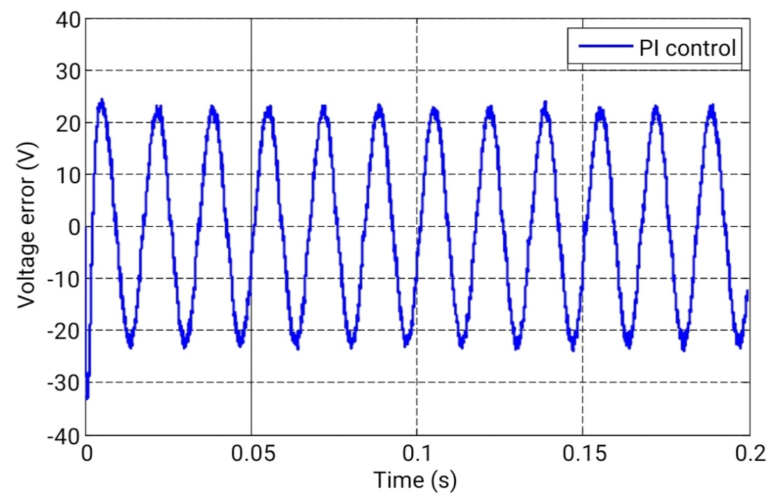

**Fig.4.9: Dual-PI controlled inverter voltage tracking error**

**4.3 DQ Frame Control**

Synchronous rotating frame DQ control can be used to eliminate tracking error for AC quantities in dual-loop control systems. In the DQ rotating frame, the AC quantities in the αβ stationary frame become DC quantities as the DQ frame rotates at the same fundamental angular frequency as the AC quantities. Traditional systems with DQ control method perform both the current and voltage loops in synchronous rotating frame. Alternative methods have been reported in . Those methods only apply DQ based control to outer voltage loop. The obvious advantage of those methods is that those controls are easy to implement without generating β components. The control diagram is shown in Fig. 4.10. The state-space form equations shown as (2.7) and (2.8) describe the relationship between synchronous rotating frame and stationary reference frame .

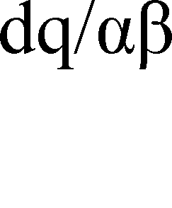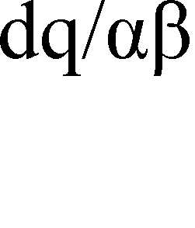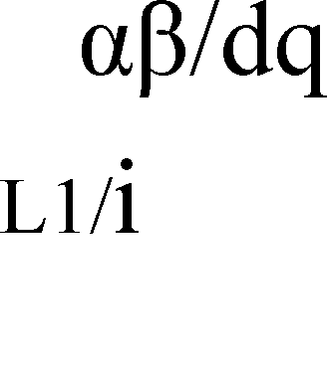

**Fig. 4.10: A DQ based control diagram of single-phase inverters**

yd cos(mt) sin(mt) xα

[yq ] = [−sin(mt) cos(mt)] [xþ] (2.7)

yα cos(mt) −sin(mt) xd

[yþ] = [sin(mt) cos(mt) ] [xq] (2.8)

Applying the DQ frame control to the single-phase H-bridge inverter, a comparison of the control performance between the two inner current feedback methods is performed. The comparison result is given in Fig. 4.11. At 0.05 s, the load changes to 1 kW from no load condition. The load reaches 2 kW at 0.1 s, and drops back to no load condition at 0.15 s. The capacitor current feedback control method shown in Fig. 4.11 is adopted since it provides more robust performance when load changes. In , the step load performance is improved by adding an additional load current feedback besides the inverter-side inductor current inner loop feedback. Doing so will increase the overall design cost since two current sensors are utilized. The voltage and current responses with step load change are shown in Fig.4.12 and Fig. 4.13, respectively. The voltage tracking error of the H-bridge inverter, where DQ frame control is applied, is shown in Fig. 4.14. The total harmonics distortion (THD) of the inverter voltage output is: 0.39 % with 1 kW load, 0.37 % with 2 kW load, and 0.40 % with no load.

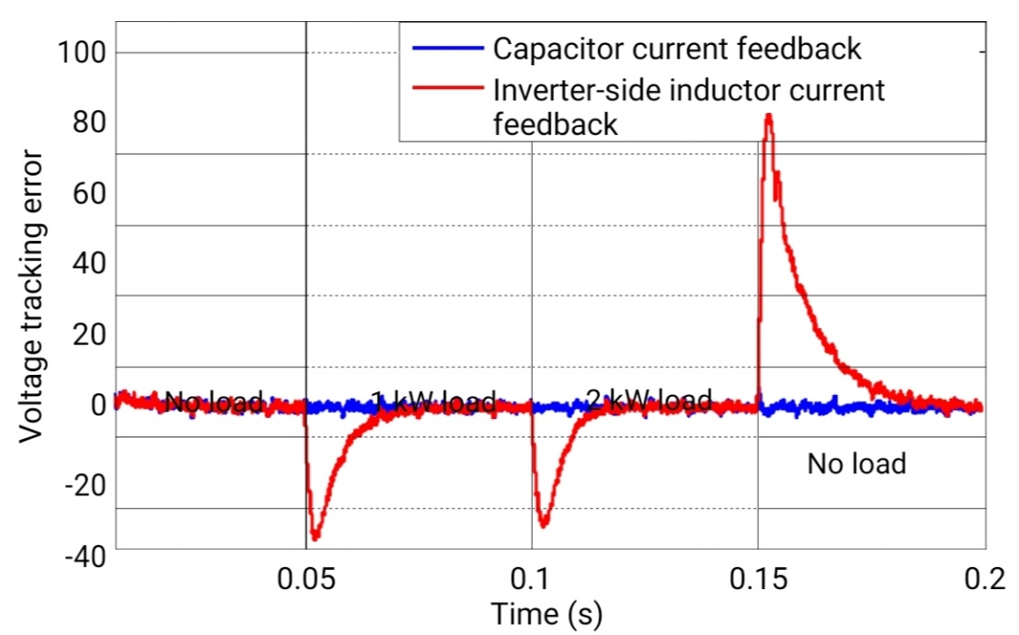

**Fig. 4.11: Comparison of control performance between the two inner feedback methods**

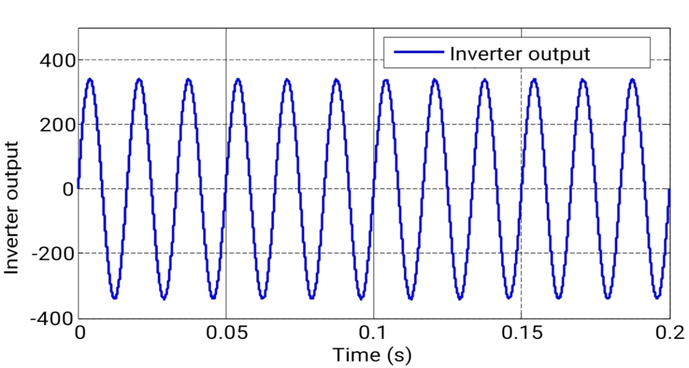

**Fig.4.12: Inverter output voltage**

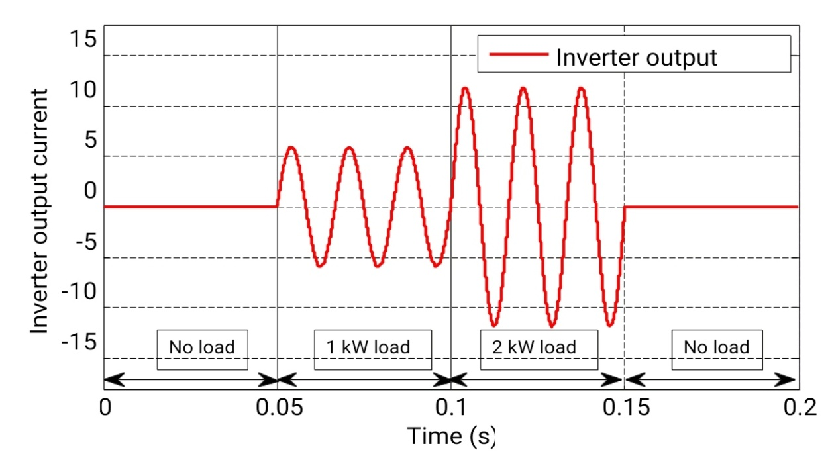

**Fig. 4.13: Inverter output current**

Fig. 4.14 shows that the DQ frame control enables the single-phase H-bridge inverter control system to achieve zero steady-state tracking response. Thus, the DQ frame control improves the inverter voltage output quality compared to the dual-PI control.

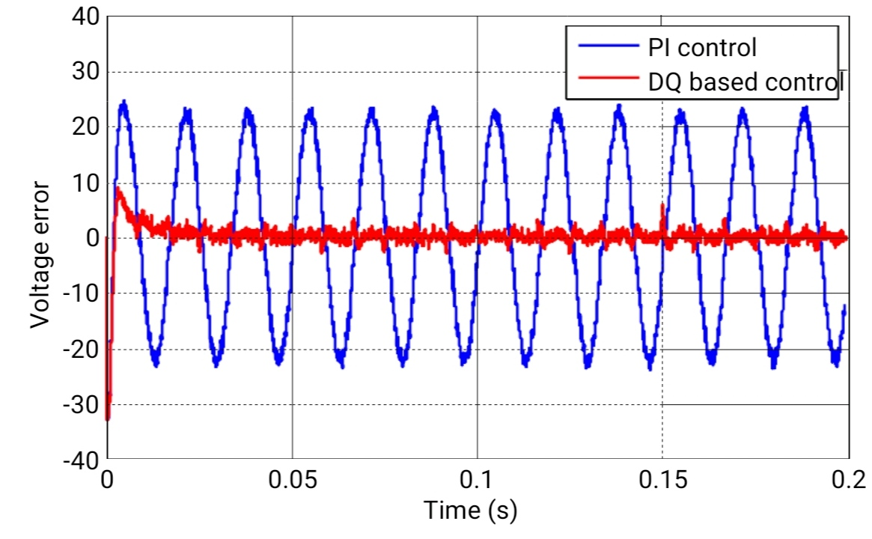

**Fig. 4.14: Voltage tracking error comparison between PI control and DQ frame control**

Generally, the power factor for a 2 kVA stand-alone inverter is between 0.707 and 1.

The inverter step load output performance with 1.4 kW resistive load and 1.4 kVar inductive load is shown in Fig. 2-15. The THD of the inverter voltage output is 0.09 %. The inverter step load output performance with 1.4 kW resistive load and 1.4 kVar capacitive load is displayed in Fig. 2-16. The THD of the inverter voltage output is 0.34 %.

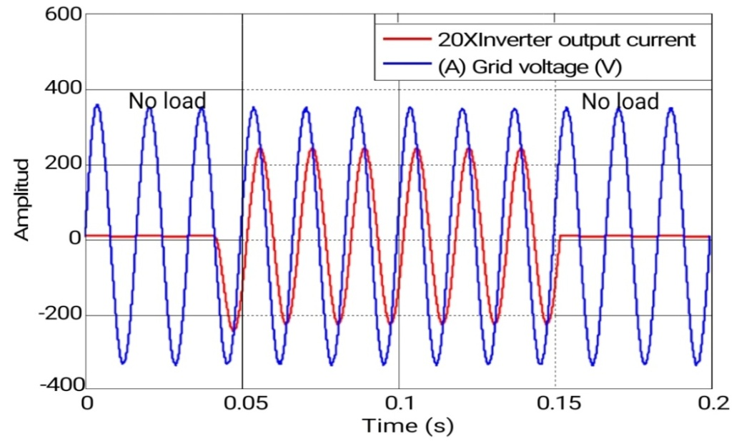

**Fig. 4.16: Inverter output with 1.4 kVar inductive load and 1.4 kW resistive load**

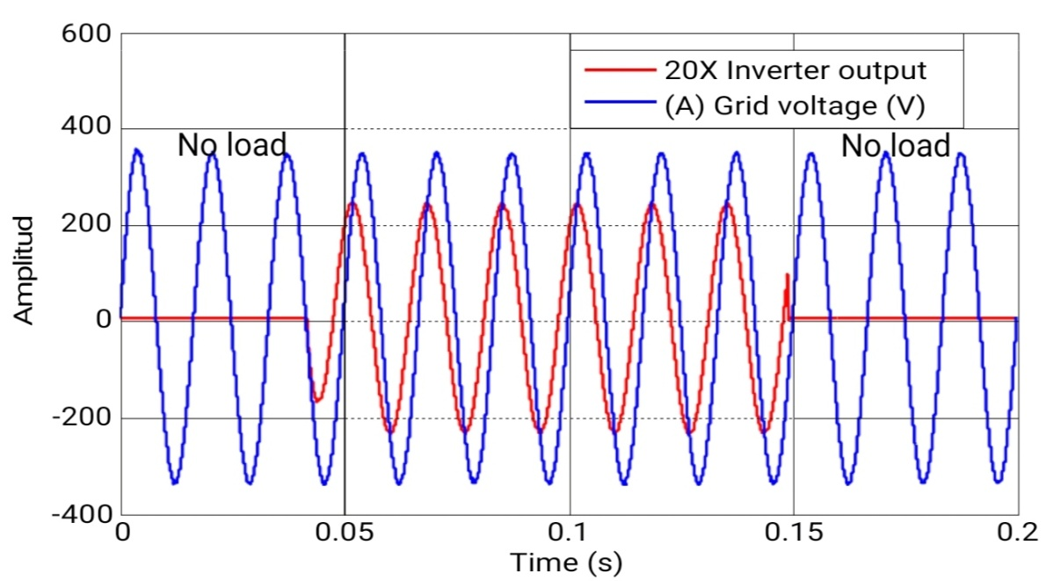

**Fig. 4.15: Inverter output with 1.4 kVar capacitive load and 1.4 kW resistive load**

**4.4 Proportional Resonant Control**

An alternative control method to achieve system zero steady-state error is using a proportional resonant controller . (2.9) shows the transfer function of a PR controller. The kp is the proportional gain term and the ki parameter is the integral gain term. The m0 is the resonant angular frequency which is set to be the line angular frequency.

Fig. 4.17 and Fig. 4.18 are Bode plots of PR controllers with the same proportional gain term and Bode plot of PR controllers with the same integral gain term, respectively From Fig. 4.17

17 and Fig. 4.18, one can observe that the magnitude of the base of PR controller increases as the integral gain term ki increases and the magnitude of the resonant part of the PR controller accrues as the proportional gain term kp increases. It can also be seen that the PR controller can provide infinite gain at the fundamental frequency which is the reason that PR controller can eliminate steady-state tracking error. In the αβ stationary frame, a PR controller is equivalent to a PI controller in the synchronous DQ frame.

A detailed analysis is given in. It is well known that the PR controller described above is sensitive to resonance frequency drift due to the implementation error caused by Tustin transformation. The nonideal PR controller shown as (2.10) provides a bandwidth for the resonant control part. A nonideal PR controller is less sensitive to resonance frequency drift. The mb is the bandwidth around the resonance frequency. Fig. 4.19 shows PR controllers with the same proportional gain term in the frequency domain. Fig. 4.20 shows PR controllers with the same integral gain term in the frequency domain.

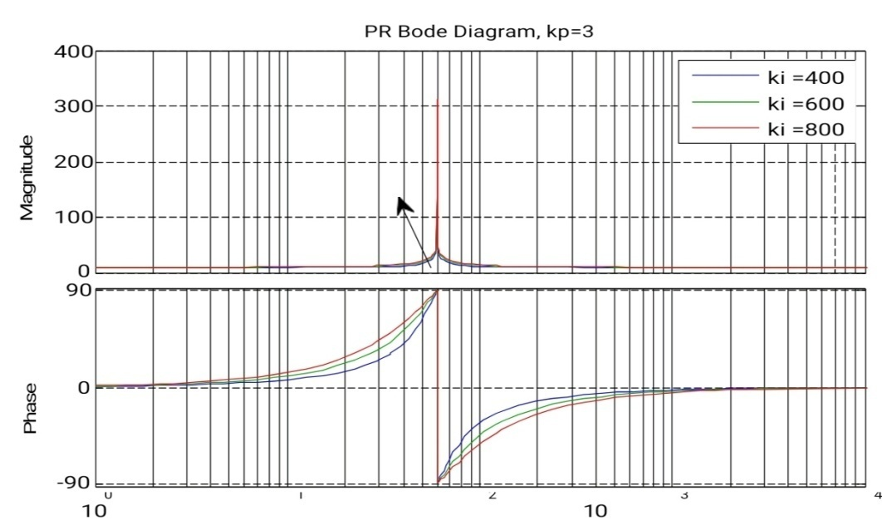

**Fig.4.16: Bode plot of PR controllers with a fixed proportional gain term**

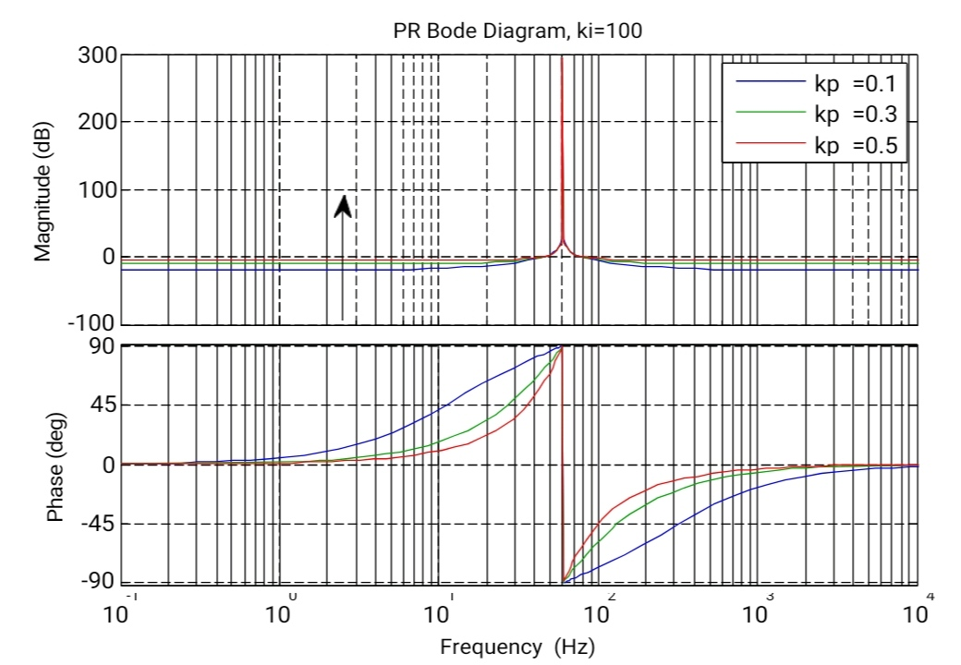

**Fig. 4.17: Bode plot of PR controllers with a fixed integral gain term**

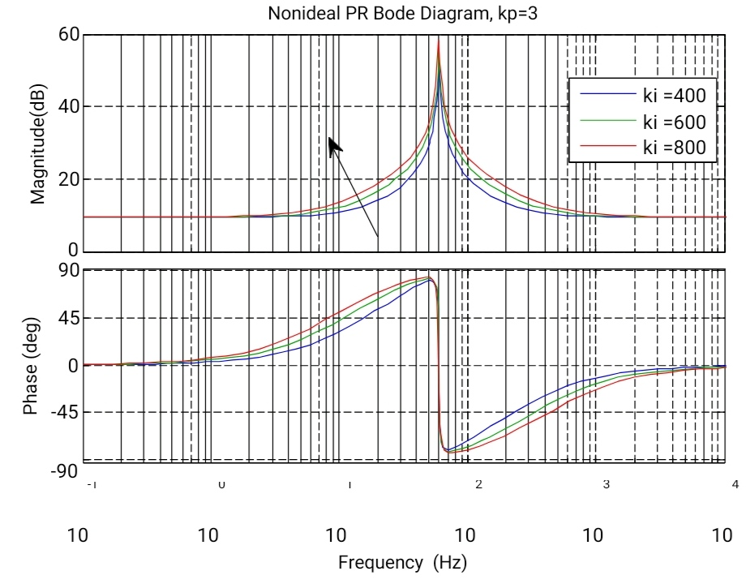

**Fig. 4.18: Bode plot of nonideal PR controllers with a fixed proportional gain term**

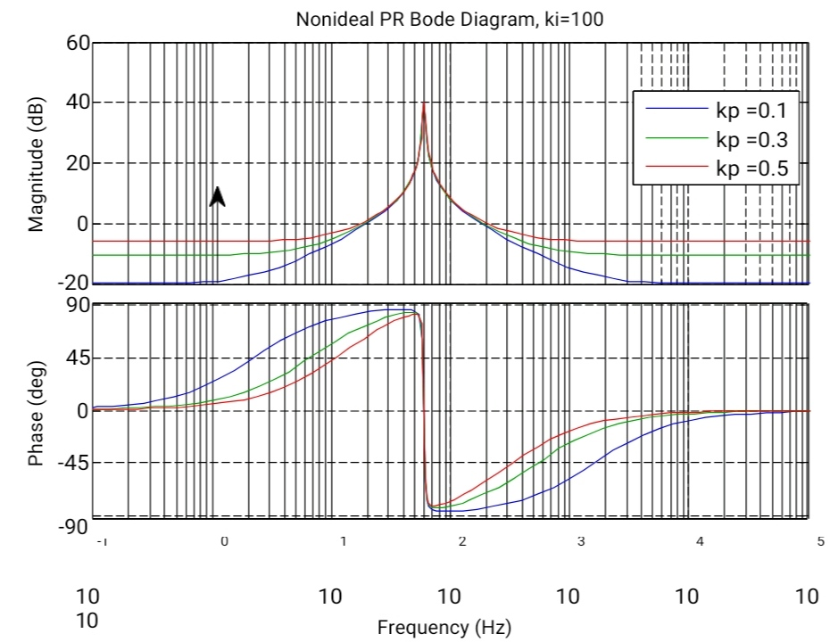

**Fig. 4.19: Bode plot of nonideal PR controllers with a fixed integral gain term**

To apply a nonideal PR controller to the outer voltage loop. The uncompensated and compensated Bode plots are shown in Fig. 4.21. The blue line is the Bode plot of the uncompensated plant. The green line shows the open-loop Bode plot of the compensated system with nonideal PR control. As we can see from Fig. 4.21, the phase margin is 49.7 degrees and the gain margin is 9.64 dB. The crossover frequency is approximately 1.1 kHz. The nonideal PR controller is given by (2.9). The unit step response is shown in Fig. 4.22.

The overshoot is 23.8 %, and the settling time is 1.17 ms. The closed-loop Bode diagram of the nonideal PR based control is shown in Fig. 4.22. The voltage tracking error is given in Fig. 4.23. As we can see in Fig. 4.23, the inverter output voltage achieves zero steady-state tracking error using the nonideal PR control method. The nonideal PR control strategy can obtain the same control performance as the DQ frame control method.

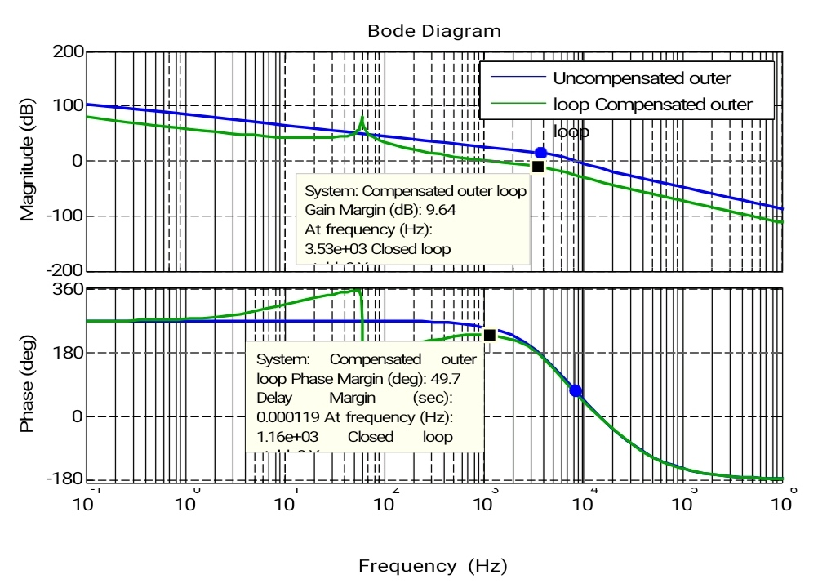

**Fig. 4.20: Bode plots of the uncompensated and nonideal PR compensated outer voltage loop.**

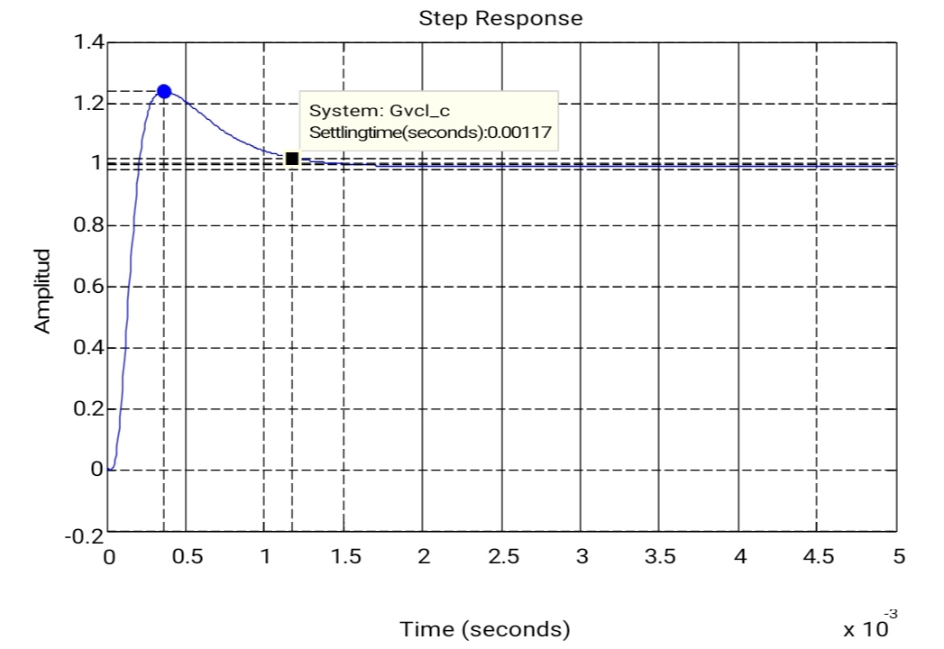

**Fig. 4.21: Step response of the compensated outer voltage loop with nonideal PR control**

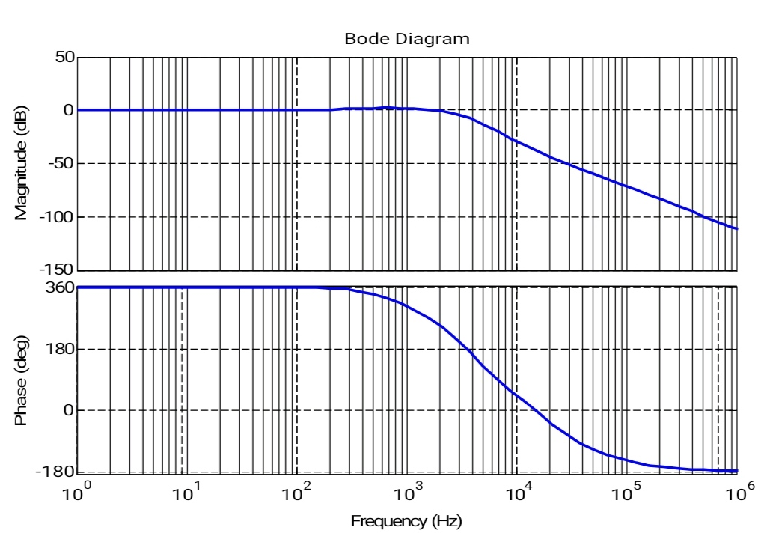

**Fig. 4.22: Closed-loop Bode plot of the dual-loop system with nonideal PR control**

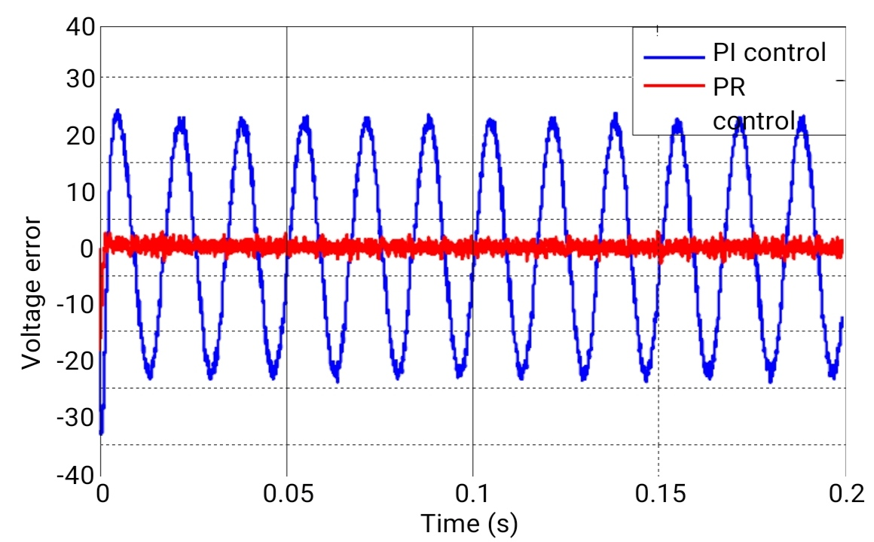

**Fig. 4.23: Voltage tracking error comparison between PI control and nonideal PR control**

**4.5 Summary**

In this chapter, the control design of a dual-loop controlled single-phase H-bridge inverter in stand-alone operation mode is discussed. To eliminate the zero steady-state control error, both the synchronous rotating frame with a DQ transformation and stationary reference frame PR controller are investigated. However, the DQ frame control mentioned above is easier for digital implementation, especially when the dual-loop PI controllers have already been designed.

Applying the DQ transformation to the outer voltage control loop, a simulation based comparison on the control performance between the two inner current feedback methods is performed. Using the DQ transformation and capacitor current feedback, the designed controllers can achieve both zero steady-state output voltage tracking error and good step load performance.

**Table 4.1: Island mode inverter control comparison**

|  |  |  |  |
| --- | --- | --- | --- |
| **Controller** | **Zero steady-state error** | **Load immunity** | **Implementation** |
| Conventional PI with inverter- side inductor current feedback | √ | √ | √√√ |
| Conventional PI with capacitor current feedback | √ | √√√ | √√√ |
| DQ based control with inverter- side inductor current feedback | √√√ | √ | √√ |
| DQ based control with capacitor current feedback | √√√ | √√√ | √√ |
| PR based control with inverter- side inductor current feedback | √√√ | √ | √ |
| PR based control with capacitor current feedback | √√√ | √√√ | √ |

**4.6 PWM PULSE GENERATION**

The Pulse Width Modulation (PWM) is a technique which is characterized by the generation of constant amplitude pulse by modulating the pulse duration by modulating the duty cycle. The block diagram representation of PWM pulse generation is shown in fig.4.24.

Analog PWM control requires the generation of both reference and carrier signals that feeds to the comparator and it’s based on some logic output, the final output is to derive the power MOSFET switches with help of IC IR2110. The reference signal output maybe sinusoidal or square wave, while the saw tooth or triangular waves are carrier signal at a frequency significantly greater than the reference.

The waveform representation of PWM pulse is shown in fig.4.25.There are various types of PWM techniques and so we get different output and the choice of the Inverter depends on cost, noise level and power efficiency. In this thesis we can select sinusoidal PWM method and it provides high efficiency up to 90% and it compatible with today’s digital microprocessors.

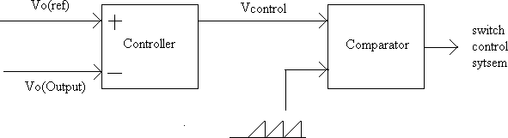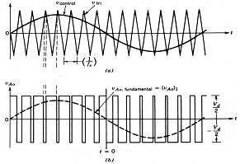

**Fig.4.24 Generation of PWM pulse Fig.4.25 Pulse waveforms**

The rate (or frequency) at which the power supply must switch can vary greatly depending on load and application. For example, switching has to be done several times a minute in an electric stove; 120 [Hz](https://en.wikipedia.org/wiki/Hertz) in a lamp dimmer; between a few kilohertz (kHz) and tens of kHz for a motor drive; and well into the tens or hundreds of kHz in audio amplifiers and computer power supplies. The main advantage of PWM is that power loss in the switching devices is very low. When a switch is off there is practically no current, and when it is on and power is being transferred to the load, there is almost no voltage drop across the switch. Power loss, being the product of voltage and current, is thus in both cases close to zero. PWM also works well with digital controls, which, because of their on/off nature, can easily set the needed duty cycle. PWM has also been used in certain [communication systems](https://en.wikipedia.org/wiki/Signalling_(telecommunication)) where its duty cycle has been used to convey information over a communications channel.

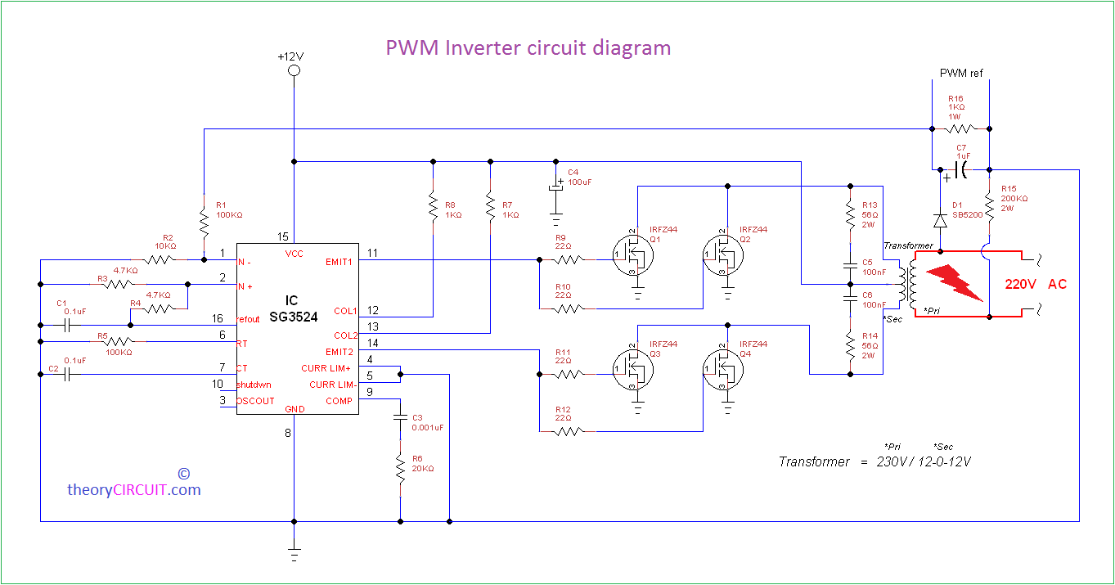

**Fig.4.26 PWM inverter circuit diagram**

**Construction and Working**

This Inverter circuit contains three stages,

1. PWM Switching Pulse Generator
2. Switching Device
3. Step up Output Driver

The PWM switching pulse generator is the main part of this circuit, which is responsible to produce PWM pulse according to the sine wave reference . The IC SG3524 gives fixed frequency PWM that can be varied by RT and CT element values.

Output from Emit1 and Emit2 pins are directly fed into Switching device that is constructed by N channel MOSFET IRFZ44, the Q 1 and Q2 are drive by Emit1 output. Q3 and Q4 MOSFET are drive by Emit2 output from SG3524.

The step up Output driver contains a transformer 230V primary to 12-0-12V secondary with 2 Amp current rating and  this transformer connected in Reverse to step up the voltage output. Sample output is taken by the small circuit to give the reference feedback to PWM regulator SG3524.

The square wave inverter are very simple and easy to make but that is not suitable for sensitive Electric appliances, Modified sine wave inverters are gives output as close as to the sine wave but not pure as much we have receive from wall outlet. PWM (Pulse Width Modulation) signal based inverters are produce output as pure sine wave and it can be used for any electric appliance that meets the inverter output range.

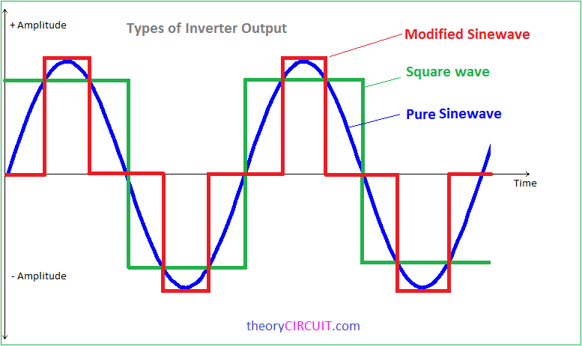**fig.4.27 type of inverter output**

**4.6.1 Major advantages of PWM technique**

* Reduces Switching Losses
* The Dc power supply is utilized that it’s to delivers a higher output voltage with the same DC supply.
* Linearly controls in voltage and current

**4.6.2 Disadvantages of PWM technique**

* Power will be variable because of varying in width of pulse. Transmitter can handle the power even for maximum width of the pulse.
* Bandwidth should be large to use in communication, should be huge even when compared to the pulse amplitude modulation.

**4.7 HYSTERESIS CONTROLLER**

The rectified sinusoidal hysteresis controller has an obligation of controlling and shaping the output current in such it matches the reference current. Fig.4.28. presents the conceptual diagram of the rectified sinusoidal hysteresis controller. According to Fig.4.29, the controller receives two inputs, the reference current (*I*ref) and the output current (*I*o). *I*ref is generated by the Arduino microcontroller. The output current (*I*o ) is measured and signal-conditioned by HCPL788J, an optical isolated sensor. A difference amplifier, OP-07D with unity gain, then subtracts both inputs; hence the error signal is generated by, Ierror = Io – Iref

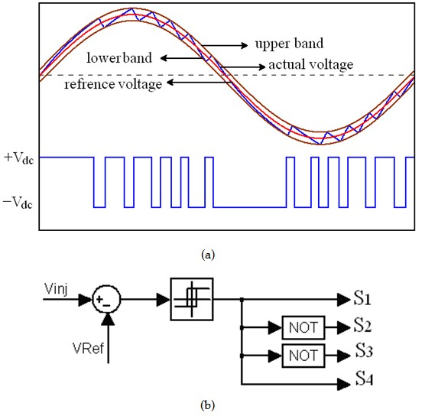

**Fig.4.28 Hysteresis controller**

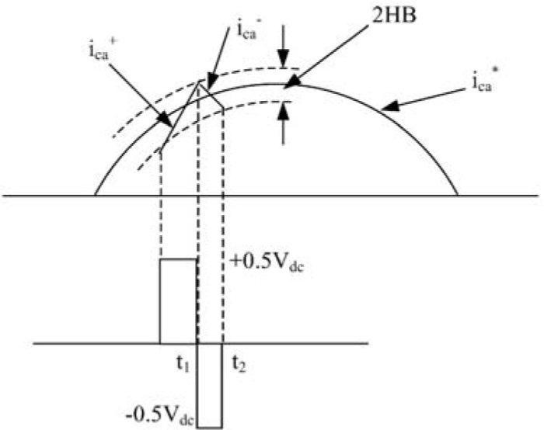

**Fig.4.29 Hysteresis gap output**

The hysteresis controller, THS4021ID, compares the error signal whether it is out of the allowance gap or not, as referred in Fig.4.29. This allowable gap is referred from to Fig.4.29, is called “hysteresis gap” or hysteresis band (HB)”, and is defined by,



Hysteresis band *=*HB= where =±12V

The harmonic performance of the half-bridge inverter under the fixed- and variable-band hysteresis control is analyzed. Results computed from the developed models are compared to those obtained from time-domain simulations using MATLAB/Simulink. Multiple simulation studies are conducted to study the harmonic response of the inverter under line and control parameter variations. The grid-connected inverter of [Fig.1](https://www.intechopen.com/books/applications-of-matlab-in-science-and-engineering/modeling-simulation-of-hysteresis-current-controlled-inverters-using-matlab#F1) is simulated in Simulink using:*Vc*=400 *V*, *Vsa*=120  *Vrms*, *f*1=60 *Hz*, *R*=1.88 *Ω*, and*L*=20 *mH*. In order to limit the THD of the line current to 10%, the line current tracks the sinusoidal reference *i*∗*a*=2–√⋅15⋅sin(*ω*1*t*)  *A* within the maximum relay bandwidth of*ε*=*εo*=2.82 *A*.

**4.8 ZERO CROSSING DETECTOR**

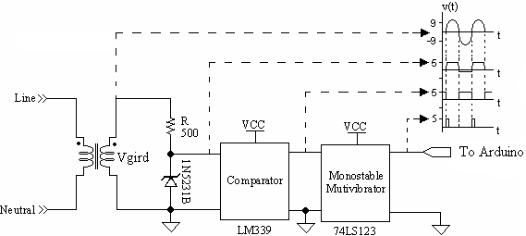The zero-crossing detector is a sensor which detects the rising edge of grid voltage; it generates the periodic pulse signal representing the frequency and the positive signal of grid voltage. This periodic signal is utilized in two control algorithms. First, under the current sink algorithm, the Arduino microcontroller detects it as the interrupt and starts executing the rest of the program after the interrupt have occurred. Second, it is used in islanding algorithm; this algorithm monitors the grid frequency and halts program if any fault conditions occur.

According to Fig.4.30, the 220- Vrms grid voltage is attenuated to be a 9-Vrms voltage by a 50-Hz voltage transformer. The zener diode, 1N5231B, limits this attenuated voltage to a 5-Vpk signal. LM339, a quad-comparator IC, reconstructs this signal into a square wave signal. Finally, 74LS123, a monostable multivibrator, converts the square wave signal to the periodic pulse signal

**Fig.4.30.Diagram of zero-crossing detector**

CHATER 5

**MATLAB/SIMULINK RESULT**

* **MATLAB Simulink modal of grid connected single phase inverter**
* **Result and Output**
* **Error output**

**5.MATLAB/SIMULINK RESULT**

The inverter was implemented and simulated using the simulink and simpowersystem tool of MATLAB 7.10.0 (R2009a). Initially the solar radiation and temperature are given as an input to the PV model. According to the inputs given the PV panel produces an output voltage. The above fig.5.1 shows the simulation model single phase inverter connected with the RL grid.

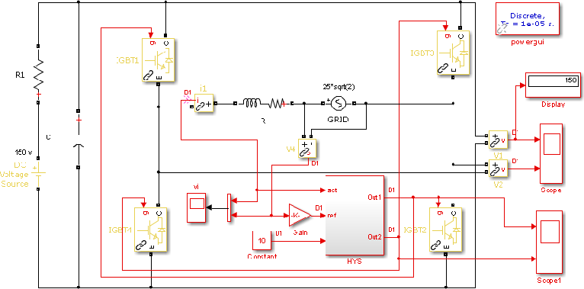

**Fig.5.1. single phase grid connected inverter model**

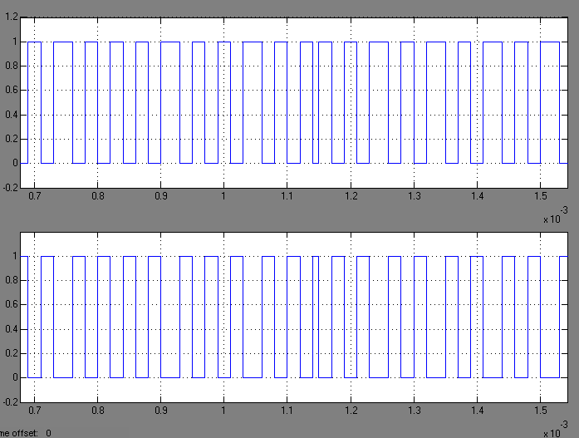The output of PV model is not constant and it is too small. So in order to boost up the voltage and make the output as constant irrespective of the change in temperature the boost converter is introduced. Then the boosted voltage is converted into AC component by using an inverter and the developed power is injected into the grid. From the fig.5.2 is gating pulses of the inverter switching module.

**Fig.5.2.Gating pulses of the inverter**

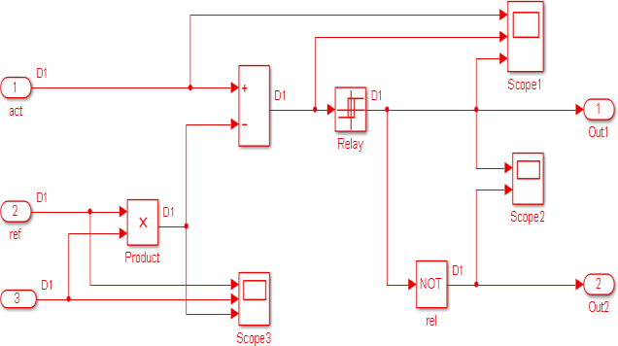

**Fig.5.3.Hysteresis controller MATLAB / Simulink model**

The detailed parameters of the inverter, solar pv array, grid and other components specification are for simulation is shown in table

|  |  |
| --- | --- |
| **Parameters** | **specifications** |
| Solar Insolation | 1000w/m2 |
| Nominal solar array voltage | 120 volts |
| Grid voltage | 230 volts |
| Grid frequency | 60 Hz |
| Inverter current | 10 A |
| DC link Capacitor | 1000uF |
| Filter Inductor | 5mH |
| Transformer | 1 : 1 |
| Inverter Switching Frequency | 20KHz |
| Load Resistor | 100Ω |

The Hysteresis controller is used to generate the PWM pulses. Fig.5.4 shows the MATLAB /simulink model of the hysteresis controller and Fig.5.5 and 13 are the input and output waveforms of the hysteresis controller model.

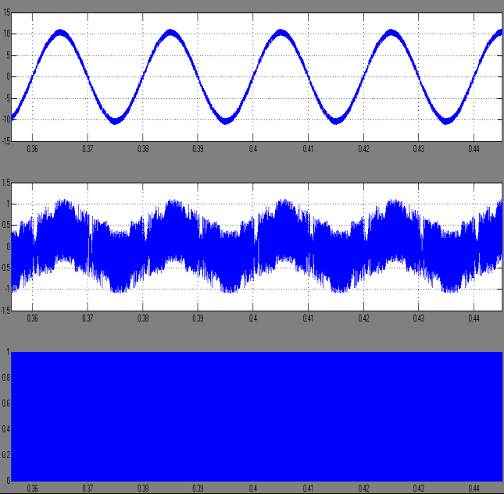

**Fig.5.4.Hysteresis controller output**

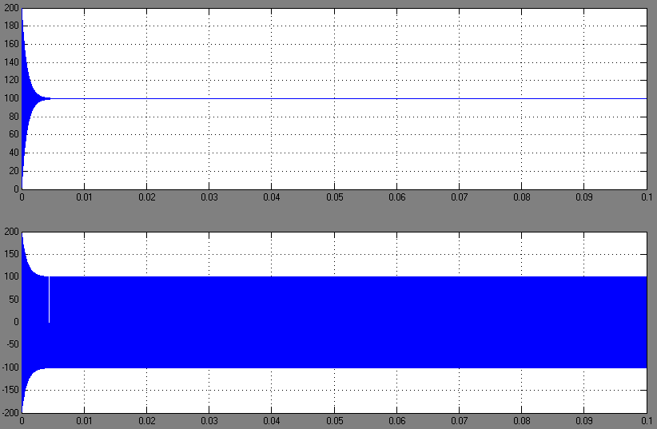

**Fig.5.5.Error output waveform**

Grid current and voltage waveforms are shown in fig. 5.6. From this Fig Grid current and voltage waveforms are positive. So, the power at the input side of the inverter is positive. Hence we say that act as a source. When the grid voltage and inverter current both of them in-phase and it provides power factor is nearly unity. The current flows from the grid to inverter. Hence we absorb a power from the utility grid. So, our inverter acts as a load.

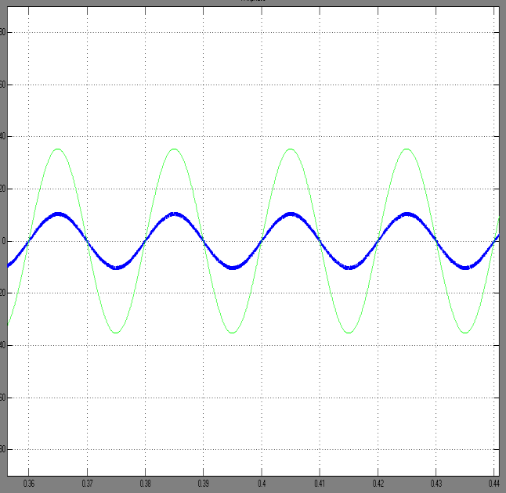

**Fig.5.6.Grid current and voltage in-phase waveform**

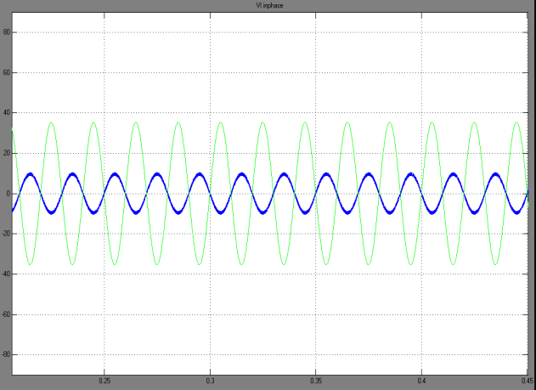

**Fig.5.7.Grid current and voltage out of phase waveform**

Grid current and voltage waveforms are shown in fig. 5.7. From this Fig we clearly examine that the voltage is positive and the current is negative ie., the current phase is shifted to 1800 (or) out of phase with grid voltage. So, the power is negative and therefore it acts as load. The current flows from the inverter to the grid. Hence we inject a power to the utility grid.

* Matlab function used:

function a = fcn(x,ma,shift)

shift_k=shift*pi/180; %convert degree to rad/s

a = (ma*(sin((x)+shift_k))); %reference voltage



**Fig.5.8. MATLAB simulink modal by using matlab function control**

**CONCLUSION**

The proposed design of single phase grid connected inverter system has been analysed and simulated by using MATLAB/SIMULINK. The output of solar PV power generation system is used to inject a power into the utility grid and it also used to feed a single phase residential load. Thus, this proposed configuration can greatly reduces the existing power demand, limits the use of conventional power generation techniques and also it is the only means to tackle the future power requirement. It saves the fossil fuels from depletion, limits global warming and keeps the environment clean and green.

Several PLL methods have been reviewed and analyzed, and the SOGI based grid synchronization has been chosen for its superior harmonic filtering capability, fast response, and simplicity. The simulation and test results validated that the active power and reactive power were decoupled with the grid synchronization unit and the reactive power could be either injected into the grid or absorbed from the grid. In the test, the maximum reactive power absorbed from the grid is 299 VAR, and the maximum reactive power sent out to the grid is 435 VAR.

The tested power factor ranges from 0.86 leading to 0.80 lagging. Both the simulation and experimental results showed that the THD of the grid-tied inverter output current, which is less than 5 %, satisfied IEEE 519-1992 and 1547 standards for distributed resources.

**REFRENCES**

[1]. Alamelu Nachiappan,Sundararajan.K and Malarselvam.V “Current controlled voltage source Inverter using Hysteresis controller and PI controller”, IEEE, 2012.

[2]. Omar David Munoz,”Design strategy for a 3- phase Variable Frequency Drive (VFD)”, senior project, Electrical Engg Dept, California polytechnic state University, San Luis obispo.2011.

[3]. Li wang and Ying-Hao Lin, “Dynamic Stability analysis of a photovoltaic array connected to a Large utility Grid”, IEEE 2000.

[4]. H.M.Abdar, A.chakravarthy, D.H.Moore, J.M. Murray and K.A.Loparo,”Design and Implementation a Specific Grid-Tie Inverter for an Agent-based Microgrid.

[5]. Single-phase grid-connected photovoltaic system using rectified sinusoidal hysteresis current control, Mr. Chainon Chaisook, Assoc. Prof. Dr. Ake Chaisawad Dr.Veerapol Monyakul, Control System and Instrumentation Engineering, King Mongkut7s University of Technology Tho~lburi,2002

[6]. Balaji Siva Prasad, Sachin Jain and Vivek agarwal, “Universal Single-Stage Grid connected Inverter”, IEEE Trans. Energy Convers, vol-23,no-1, pp.128-137,March- 2008.

[6]. S.M.Cherati,N.A.Azli,S.M.Ayob and A.Mortezaei, “Design of a current mode PI controller for a Single-phase PWM Inverter”, IEEE Applied Power Electronics Collloquim(IAPEC)”, 2011.

[7]. Power Electronics by M.H.Rashid.

[8].Power Electronics by Dr.P.S.Bimbhra, Kanna publishers, 4th Edition, 2010.